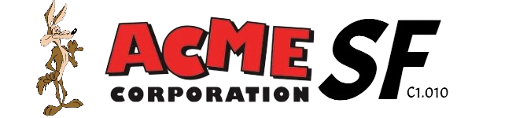

February 16th, 2024

Analysis report

**Repository: https://github.com/C1-010/Acme-SF-D01**

Group: C1.010

García Rivero, Andrés - [andgarriv@alum.us.es](mailto:andgarriv@alum.us.es)

López Cubiles, Antonio José - [antlopcub@alum.us.es](mailto:antlopcub@alum.us.es)

Nieto Vicioso, Javier - [javnievic@alum.us.es](mailto:javnievic@alum.us.es)

Díaz Ordoñez, Pablo -  [pabdiaord@alum.us.es](mailto:%20pabdiaord@alum.us.es)

Sevillano Barea, Alejandro - [alesevbar@alum.us.es](mailto:alesevbar@alum.us.es)

Content Table

1. Executive Summary 2

2. Revision Table 2

3. Introduction 2

4. Contents 2

5. Conclusions 2

6. Bibliography 2

# 1. Executive Summary

# This report is about the problems we have encountered when reading each and every one of the requirements of the deliverable.

# 2. Revision Table

|  |  |  |
| --- | --- | --- |
| Revision number | Date | Description |
| 1 | [15/02/2024] | Creation of the report and completion of its first version. All required information has been provided. |
| 2 | [16/02/2024] | Minute changes. |

# 3. Introduction

# This report provides a comprehensive analysis of Deliverable 1, aiming to inform decision-making and the rationale behind each decision. Through a detailed examination of the requirements outlined in the deliverable, valuable insights and specific recommendations are offered. Our objective is to present an objective assessment of Deliverable 1 to inform decision-making.

# 4. Contents

Intentionally blank.

# 5. Conclusions

We haven't encountered any issues when reading and implementing the requirements.

# 6. Bibliography

Intentionally blank.